**ETL Documentation**

**Staging Screenshots:**

RevenueStreams (Control Flow):

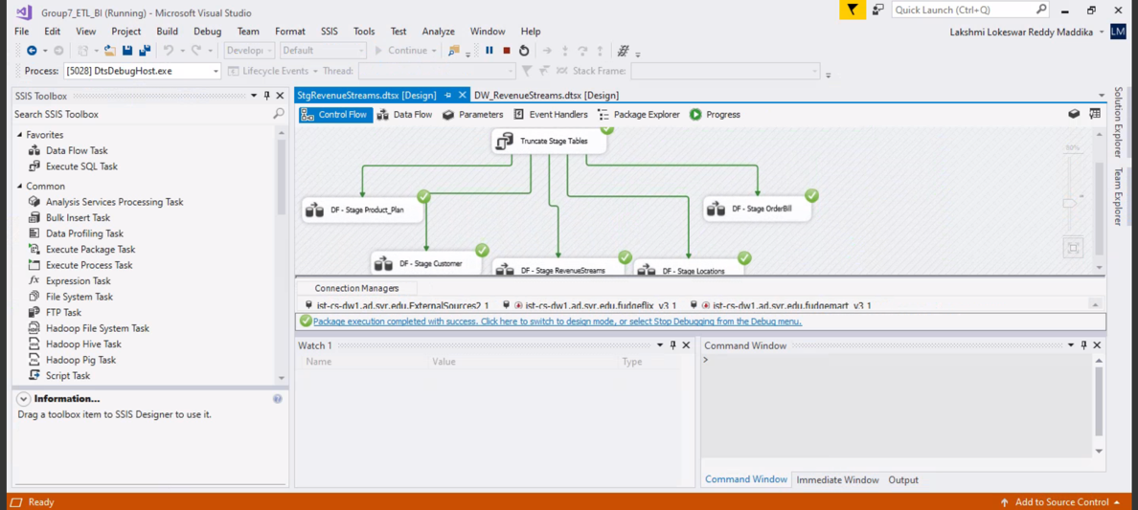

Product_Plan (Dimension Table):

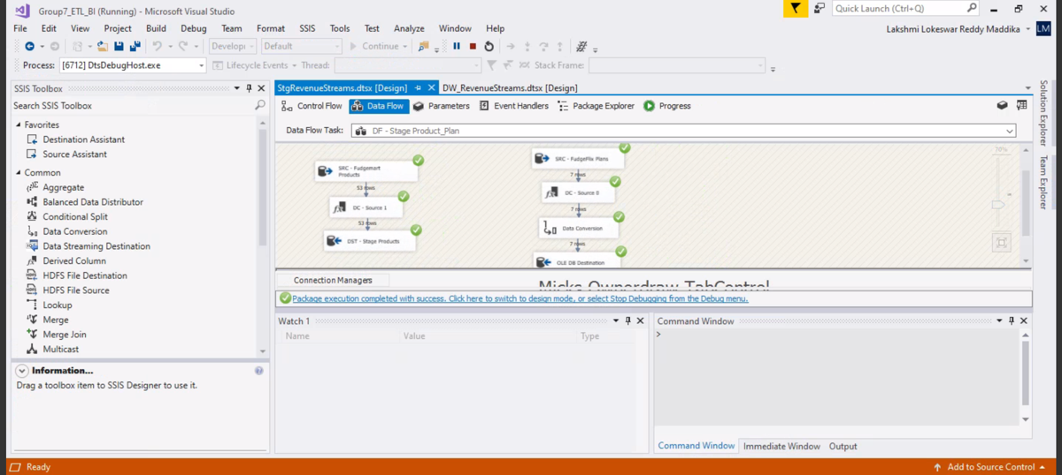

Customer (Dimension Table):

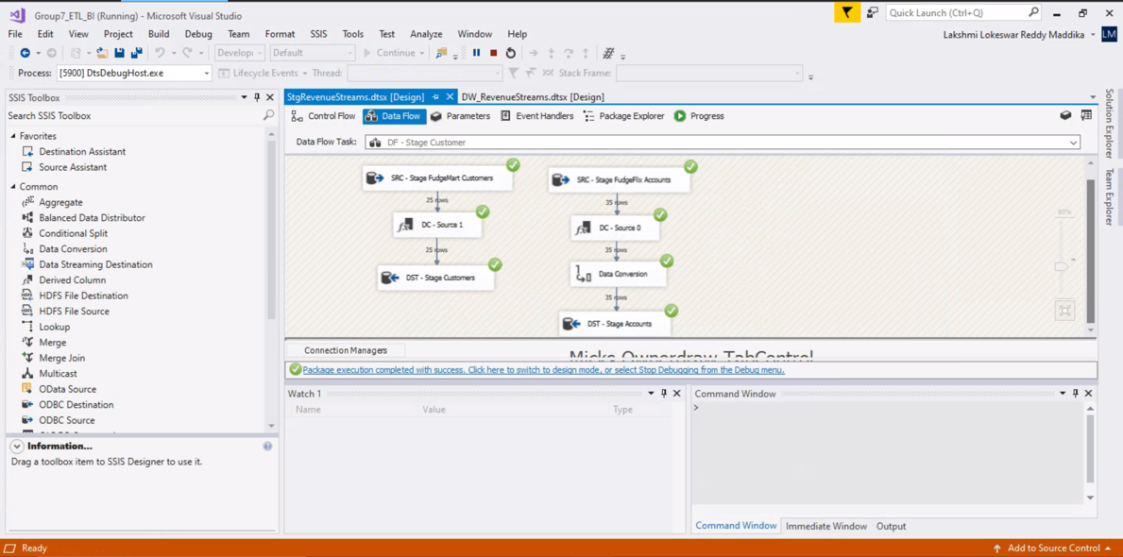

Locations (Dimension Table):

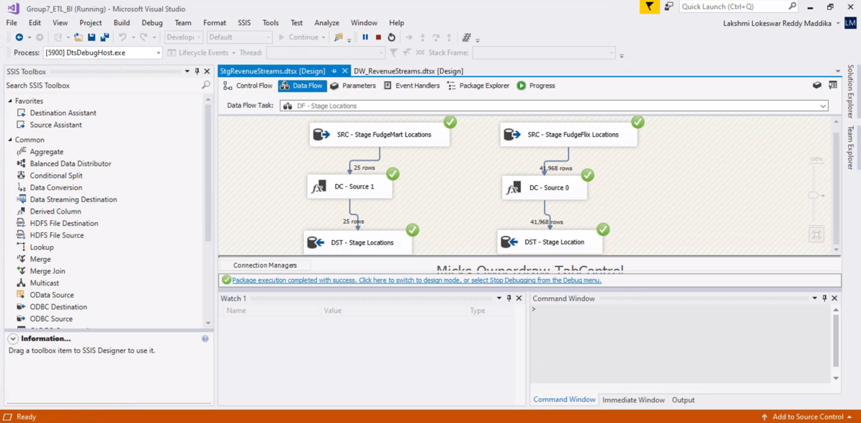

OrderBill (Dimension Table):

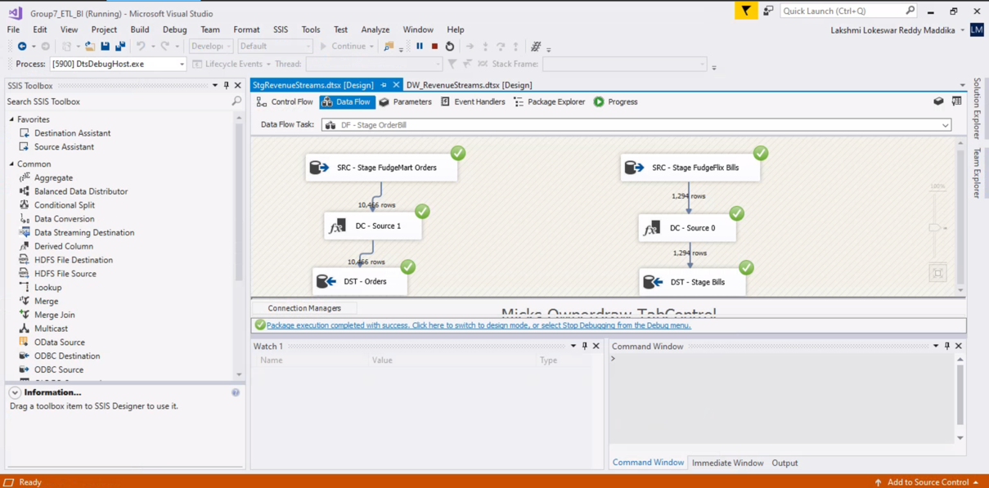

RevenueStreams (Fact Table):

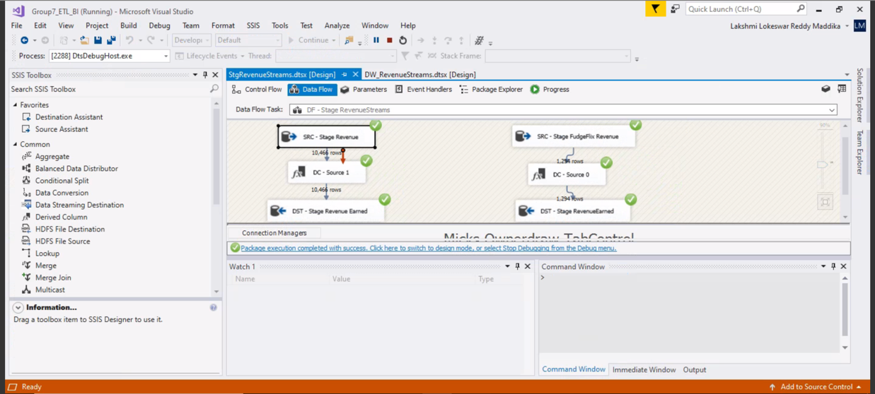

**Data Warehouse Screenshots:**

RevenueStreams (Control Flow):

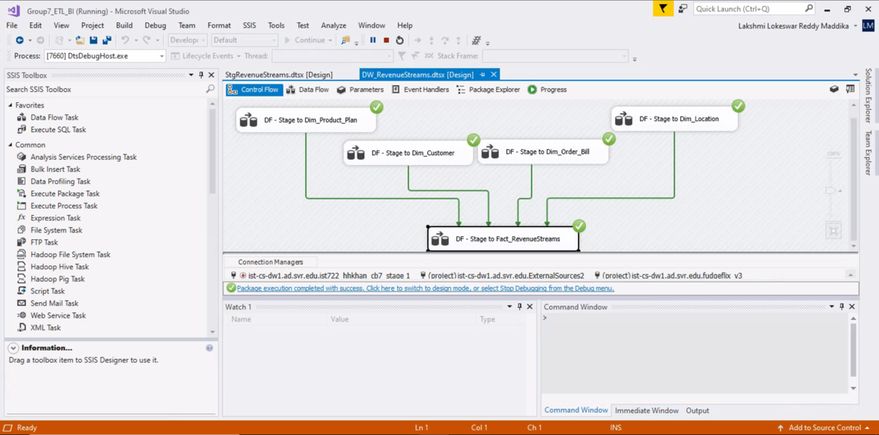

Dim_Product_Plan (Dimension Table):

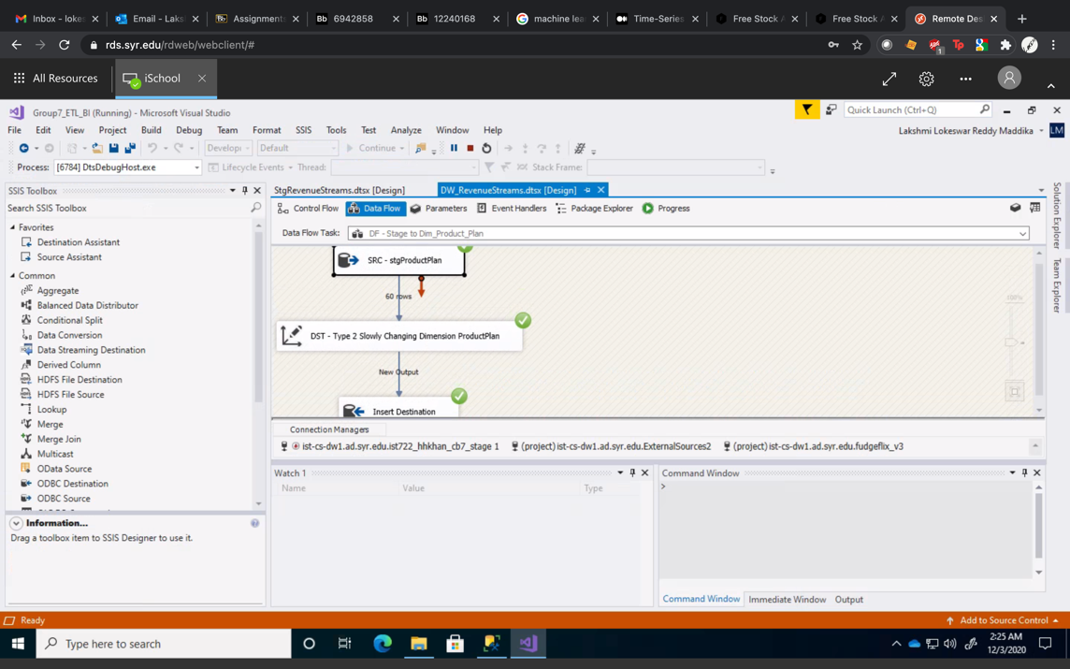

Dim_Customer (Dimension Table):

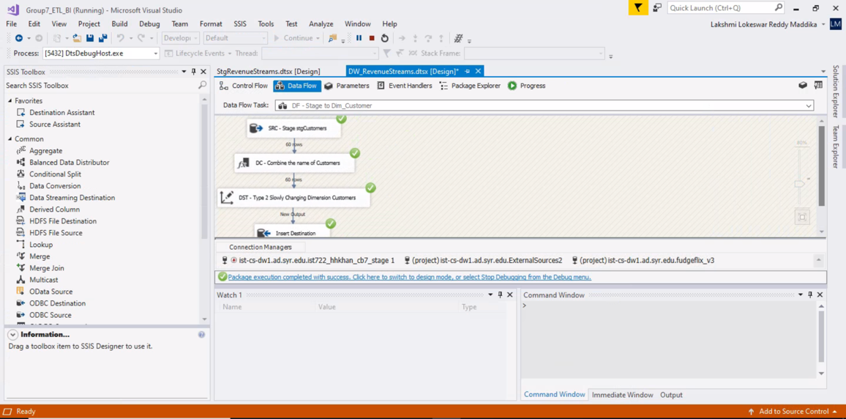

Dim_Location (Dimension Table):

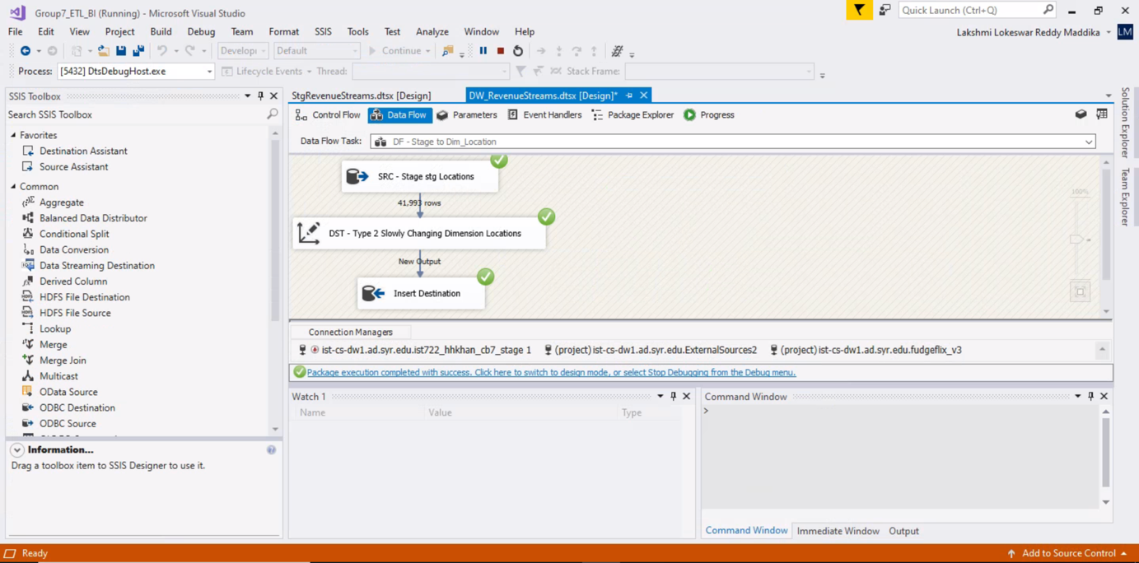

Dim_Order_Bill (Dimension Table):

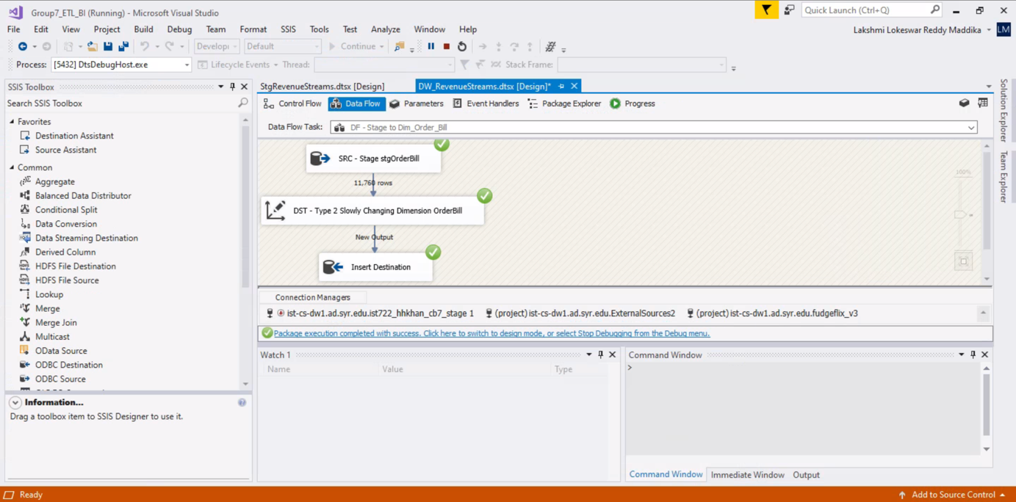

Fact_RevenueStreams (Fact Table):

